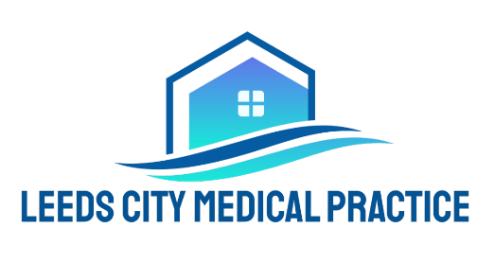
FILMING, RECORDING AND
PHOTOGRAPHY POLICY

At Leeds City Medical Practice, we are committed to maintaining a safe, respectful, private, and professional environment that upholds patient confidentiality and dignity, consistent with NHS and CQC standards.

1. Recording Consultations with Clinicians

Patient Recording for Personal Use
- Patients may request to record their medical consultation for personal reference — for example, to help recall important clinical information or share details with carers.
- While UK GDPR may not prevent recording for personal use, staff privacy and dignity remain important and good practice is to seek clinician consent before recording.
Consent and Transparency
- Patients should inform the clinician before recording begins and confirm consent has been granted.
- Recording should be overt (open and agreed) and not covert. Covert recording may undermine trust and professional relationships.
Use and Sharing
- Recordings taken for personal use must remain private and may not be shared on social media or in any public forum.
- Sharing patient or staff images / audio publicly without consent may jeopardise confidentiality and privacy, and may lead to professional, legal, or data protection concerns.
Policy Enforcement
- If a patient records without consent or displays recordings publicly, we will discuss the issue with the individual and seek explanation.
- Repeated or serious breaches that affect safety, privacy, or trust may lead to formal warnings and could affect the patient’s registration at the practice.

2. Recording / Photography in Public Areas
No Unauthorised Recording
- Recording or photographing in communal areas such as waiting rooms, reception, corridors, or other shared spaces is not permitted, unless all persons in the area (patients and staff) have given explicit consent.
- This reflects the expectation that all individuals in NHS environments have a right to privacy and should not be recorded without their consent.

Protection of Others’ Privacy
- Unauthorised recording may inadvertently capture information pertaining to other patients, their treatment or personal data, which must remain confidential in line with NHS confidentiality principles.

3. Social Media and Posting on Digital Platforms

Restricted Use of Recordings
- Content recorded within our practice that includes identifiable staff, patients, or clinical interactions must not be uploaded, streamed, or shared on social media or third-party platforms.
- Posting such material without consent may breach privacy rights and confidentiality expectations of NHS professionals and could lead to legal or regulatory concerns.
Professional Respect and Feedback
  - If you have feedback or concerns about your care, we encourage use of the practice’s formal complaints procedure rather than posting on social media. This ensures issues are addressed appropriately and respectfully.

4. Why These Rules Matter

These policies support:

Patient and Staff Confidentiality
- Protecting personal and clinical information in line with NHS information governance principles.
- Respecting privacy of individuals in communal and clinical areas.
Professional Integrity
- Encouraging open, transparent communication between clinicians and patients.
- Supporting a trusting patient-clinician relationship, a key expectation under CQC and NHS standards.
Legal and Ethical Expectations
  - Aligning with guidance that recordings involving patients and clinicians should be consensual, transparent, and handled with sensitivity to privacy.

5. Further Considerations
  - Clinical recordings made by the practice (e.g. for care and treatment, or diagnostic purposes) follow separate NHS information governance processes and consent procedures.
  - Any recording intended for purposes beyond personal use (e.g. training, research, quality improvement) will only take place under explicit written consent in accordance with professional and NHS guidance.

